Assignment – 06
Operators
- Write a query to display the job titles whose MAX_SALARY is less than or equal to 20000. Write a query to find employees with a salary greater than 5000.
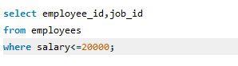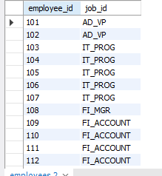

- Write a query to display employees who do not belong to department 90.
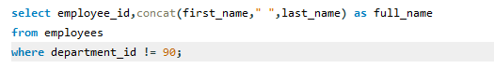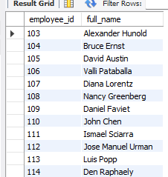

- Write a query to find employees with a salary less than 4000.
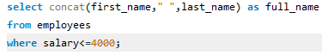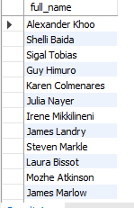
- Write a query to display employees whose COMMISSION_PCT is not null. Write a query to display employees whose MANAGER_ID is null.
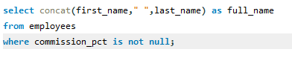
- Write a query to find employees in departments with IDs greater than 50.
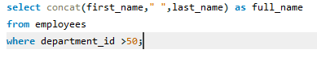
- Write a query to display the employees with DEPARTMENT_ID equal to 90.
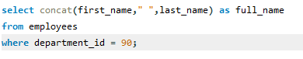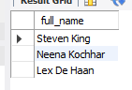
- Write a query to display employees in department ID 100, 200, or 300.
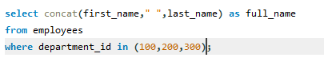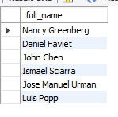
- Write a query to display jobs where MAX_SALARY is greater than or equal to 10000.
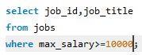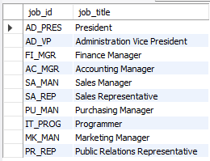
- Write a query to find departments where the location is 1700
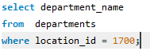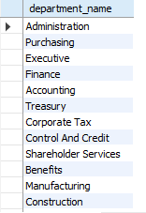
- Write a query to find countries where REGION_ID is greater than or equal to 2.
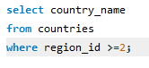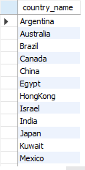
- Write a query to find employees whose MANAGER_ID is less than 103.
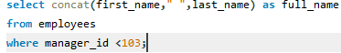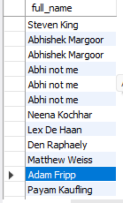
- Write a query to find employees whose SALARY is greater than or equal to 8000.
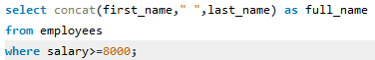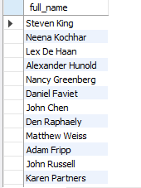
- Write a query to find employees in departments with IDs less than or equal to 60
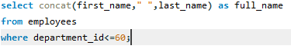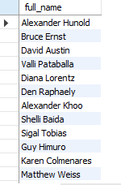
- Write a query to find employees whose SALARY is between 4000 and 8000.
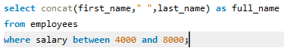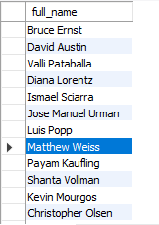
- Write a query to display the job titles where the minimum salary is greater than 6000.
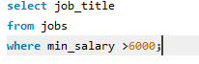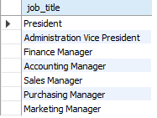
- Write a query to find employees whose salary is not equal to 5000.
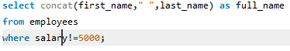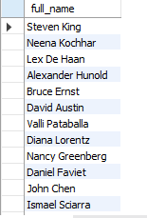
- Write a query to display departments whose MANAGER_ID is not 0.
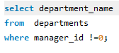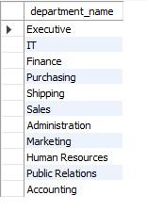
- Write a query to display the countries where REGION_ID is not equal to 2.
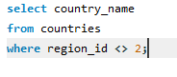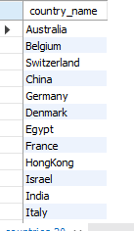
- Write a query to find employees whose salary is exactly 6000.
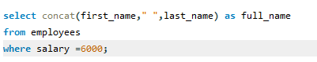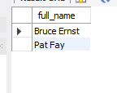
- Write a query to display employees where SALARY is greater than 10000 or DEPARTMENT_ID is 60.
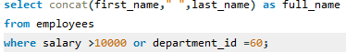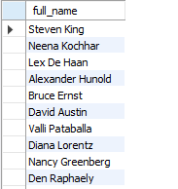
- Write a query to find employees whose salary is less than or equal to 3000.
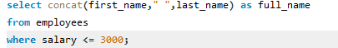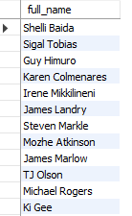
- Write a query to display employees where the DEPARTMENT_ID is equal to 60 and the MANAGER_ID is greater than 102.
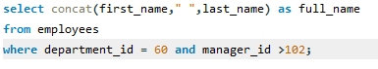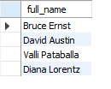
- Write a query to display employees where DEPARTMENT_ID is 100 and SALARY is greater than 10000.
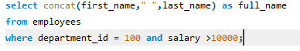
- Write a query to display departments where the DEPARTMENT_ID is not in (60, 70, 80).
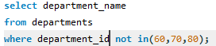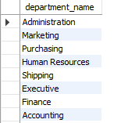
- Write a query to display job titles where the minimum salary is not less than 5000.
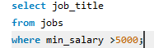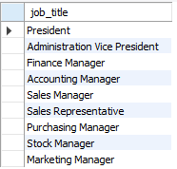
- Write a query to find employees whose department ID is not equal to 100 or 60.
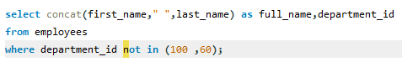
- Write a query to display employees where LAST_NAME ends with 'son'.
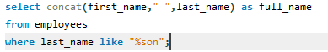
- Write a query to display employees with FIRST_NAME starting with 'J' using the LIKE operator.
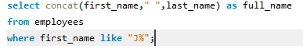
- Write a query to display employees where SALARY is greater than 8000 and DEPARTMENT_ID is 90.
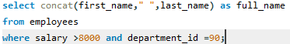
- Write a query to display jobs where the MIN_SALARY is less than 5000 or the MAX_SALARY is greater
than 20000.
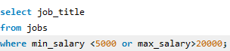
- Write a query to display employees where SALARY is greater than 6000 and DEPARTMENT_ID is either 50 or 60.
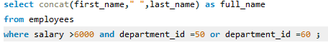
- Write a query to display countries where COUNTRY_NAME starts with 'C' and REGION_ID is greater than 1.
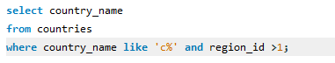
- Write a query to display employees where FIRST_NAME contains 'an and SALARY is greater than 4000.
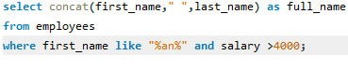
- Write a query to display departments where the location is either 1700 or 1800 using the IN operator.
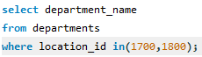
- Write a query to display employees where FIRST_NAME starts with 'A' and LAST_NAME contains 'son'.
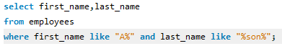
- Write a query to display employees where SALARY is greater than 5000 or DEPARTMENT_ID is 100.

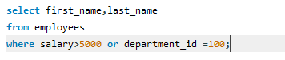

- Write a query to display countries where COUNTRY_NAME does not start with 'A' and REGION_ID is greater than 1.
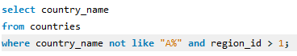

- Write a query to find employees who work in departments with DEPARTMENT_ID greater than 50 and earn more than 7000.
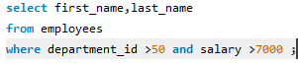
- Write a query to display employees whose salary is either greater than 10,000 or less than 3,000.
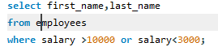
- Write a query to display employees whose salary is greater than 6000 and COMMISSION_PCT is null or less than 0.2.
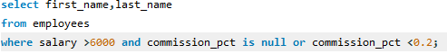
- Write a query to display employees whose hire date is within the last 10 years.
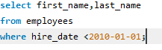

- Write a query to display employees who either belong to department 50 or have a salary greater than the average salary of their department.
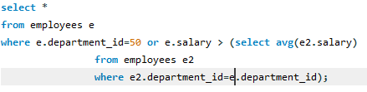

- Write a query to find all countries where the REGION_ID is greater than 2 but not equal to 4.
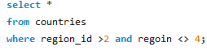
- Write a query to display all employees where SALARY is not in the range of 5000 to 10000.
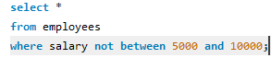

- Write a query to display employees whose HIRE_DATE is not between '1995-01-01' and '2005-12-31'.
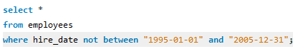
- Write a query to display employees who earn a salary greater than 5000 but are not in department 50
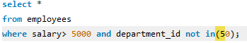
- Write a query to display employees whose salary is either greater than 10,000 or less than 3,000 but not equal
to 7,000
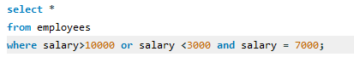
- Write a query to display job titles where the minimum salary is greater than 5000 or the maximum salary is less than 15,000.
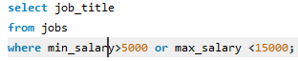
- Write a query to find jobs where the minimum salary is at least half of the maximum salary.
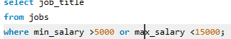
- Write a query to display employees who were hired after '1990-01-01' and have a MANAGER_ID greater than 100.
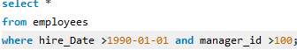
- Write a query to display employees where SALARY is greater than 10000 and the JOB_ID is either 'IT_PROG' or 'ST_CLERK'.
